**HYPOTHESIS TESTING**

Hypothesis testing is a fundamental concept in statistics, used to make decisions or inferences about a population based on sample data. Let me break it down step by step to clarify **why** and **when** we use hypothesis testing in the real world.

**Why We Use Hypothesis Testing**

1. **Uncertainty in Data**: In real-world scenarios, we often don't have access to data from the entire population (e.g., all people, products, etc.). Instead, we collect a sample, which may not perfectly represent the whole population.

Hypothesis testing allows us to make inferences or draw conclusions about the population based on this sample, while accounting for the possibility of error.

1. **Objective Decision Making**: When we want to test a claim or belief (e.g., whether a new medication is more effective than an old one), hypothesis testing gives us a structured framework to evaluate the evidence, rather than relying on gut feelings or guesses.
2. **Quantifying Uncertainty**: Hypothesis testing uses probabilities to measure uncertainty. By calculating a **p-value** and comparing it to a predefined threshold (**significance level, α**), we can objectively determine whether the observed data is consistent with our assumptions or whether we have enough evidence to reject them.

**When We Use Hypothesis Testing**

Hypothesis testing is widely used in many areas of research and decision-making. Here are a few real-world examples:

**1. Medical Studies:**

* **Example**: A pharmaceutical company wants to test if a new drug lowers blood pressure more effectively than the current standard treatment.
* **How hypothesis testing is used**:
  + **Null hypothesis (H₀)**: The new drug is no more effective than the current treatment.
  + **Alternative hypothesis (H₁)**: The new drug is more effective than the current treatment.

Researchers will conduct a hypothesis test by giving the drug to a sample group, measuring the results, and calculating whether the difference is statistically significant. If the p-value is less than the significance level (e.g., 0.05), they may conclude the new drug is more effective.

**2. Business and Marketing:**

* **Example**: An e-commerce company wants to test whether changing the design of its website will increase sales.
* **How hypothesis testing is used**:
  + **Null hypothesis (H₀)**: The new website design does not affect sales.
  + **Alternative hypothesis (H₁)**: The new website design increases sales.

The company will conduct an **A/B test**, showing the old design to half of the users and the new design to the other half. After gathering the data, they can perform a hypothesis test to see if the change in sales is statistically significant.

**3. Quality Control:**

* **Example**: A manufacturer claims their machine produces parts with an average weight of 50 grams, but the quality control department wants to test this claim.
* **How hypothesis testing is used**:
  + **Null hypothesis (H₀)**: The mean weight of parts produced is 50 grams.
  + **Alternative hypothesis (H₁)**: The mean weight of parts produced is not 50 grams.

Quality control inspectors will take a random sample of parts, measure their weights, and perform a hypothesis test to determine if the machine's output deviates significantly from the target.

**4. Social Science and Psychology:**

* **Example**: A psychologist wants to test if a new teaching method improves student performance more than the traditional method.
* **How hypothesis testing is used**:
  + **Null hypothesis (H₀)**: The new teaching method does not improve student performance compared to the traditional method.
  + **Alternative hypothesis (H₁)**: The new teaching method improves student performance.

The psychologist will test the new method with a group of students and compare their performance to a control group using the traditional method. The hypothesis test will help them decide whether the new method makes a statistically significant difference.

**Basic Workflow of Hypothesis Testing**

1. **State the Hypotheses**: Define the null hypothesis (H₀) and the alternative hypothesis (H₁). The null hypothesis represents the default assumption (e.g., no effect or no difference), while the alternative hypothesis represents what you're testing for (e.g., an effect or difference).
2. **Choose the Significance Level (α)**: This is the probability threshold for rejecting the null hypothesis. Common choices are α = 0.05 or α = 0.01. A significance level of 0.05 means that you're willing to accept a 5% chance of rejecting the null hypothesis when it is actually true (Type I error).
3. **Collect and Analyze Data**: Gather your sample data and perform the necessary statistical test (e.g., z-test, t-test). This will yield a test statistic, such as a z-score or t-score.
4. **Calculate the P-Value**: The p-value represents the probability of observing your data (or something more extreme) if the null hypothesis is true. A small p-value indicates that your sample data is unlikely under the null hypothesis.
5. **Make a Decision**: Compare the p-value to α:
   * If the p-value is less than α, **reject the null hypothesis**. This means the data provides enough evidence to support the alternative hypothesis.
   * If the p-value is greater than α, **fail to reject the null hypothesis**. This means there is not enough evidence to support the alternative hypothesis.

**Types of Errors in Hypothesis Testing**

1. **Type I Error (False Positive)**: Rejecting the null hypothesis when it is actually true (e.g., concluding a drug is effective when it is not).
   * The probability of making a Type I error is equal to the significance level (α).
2. **Type II Error (False Negative)**: Failing to reject the null hypothesis when the alternative hypothesis is true (e.g., concluding a drug is not effective when it is).
   * The probability of making a Type II error is denoted by β, and **1 - β** is called the **power of the test** (the probability of correctly rejecting the null hypothesis when the alternative is true).

**When to Use Hypothesis Testing**

1. **When comparing groups** (e.g., treatment vs. control).
2. **When validating a claim** (e.g., a company’s claim about product performance).
3. **When testing for differences** (e.g., difference in averages or proportions).
4. **When making decisions based on data** (e.g., A/B testing in business).

**Example: Hypothesis Testing in Action**

Let’s say a factory claims its lightbulbs last 1,000 hours on average. You want to test if the average lifespan is actually less than 1,000 hours based on a sample of lightbulbs.

1. **Null Hypothesis (H₀)**: The mean lifespan of the lightbulbs is 1,000 hours.
2. **Alternative Hypothesis (H₁)**: The mean lifespan of the lightbulbs is less than 1,000 hours.
3. **Significance level (α)**: 0.05.
4. **Sample Data**: You test 30 lightbulbs and get an average lifespan of 950 hours with a standard deviation of 60 hours.
5. **Test Statistic**: You perform a one-sample t-test (since you are comparing the sample mean to a population mean and don’t know the population standard deviation).
6. **P-value**: Based on the test statistic, you get a p-value of 0.03.
7. **Decision**: Since the p-value (0.03) is less than α (0.05), you reject the null hypothesis and conclude that the lightbulbs' mean lifespan is less than 1,000 hours.

**Understanding Null and Alternative Hypotheses**

1. **Null Hypothesis (H₀):**
   * The null hypothesis represents the **default assumption** or **status quo**.
   * It often states that **no effect**, **no difference**, or **no relationship** exists.
   * In real-world testing, the null hypothesis is usually the claim we test to **disprove** or **reject**.
2. **Alternative Hypothesis (H₁):**
   * The alternative hypothesis represents what you are trying to prove, such as an **effect**, **difference**, or **relationship**.
   * It challenges the null hypothesis and is accepted if there is sufficient evidence against H₀.
   * The alternative hypothesis can be either **two-tailed** or **one-tailed:**
     + **Two-tailed:** Tests for any significant difference, either higher or lower than a specified value.
     + **One-tailed:** Tests for a difference in one specific direction (e.g., greater than or less than a value).

**How to Formulate the Hypotheses**

The process of formulating null and alternative hypotheses depends on the objective of your test.

**Step-by-Step Process:**

1. **Start with a Research Question**: What do you want to investigate? For example, do you want to check if a new medication works better than the current one, or if there's a difference between two groups?
2. **Identify the Variables:** Determine the **population parameter** (mean, proportion, etc.) that you are interested in and the conditions you want to test.
3. **Formulate the Null Hypothesis (H₀):**
   * Assume that there is **no effect** or **no difference.**
   * The null hypothesis should be an **equality statement** (e.g., μ=0, p=0.5 etc.).
4. **Formulate the Alternative Hypothesis (H₁):**
   * This represents what you **want to test** for.
   * It’s typically an **inequality statement** (e.g., μ≠0, p≠0.5, μ>0, etc.).

**Detailed Examples for Different Situations**

**Example 1: Medical Testing**

* **Scenario**: A researcher wants to test if a new drug is more effective than the current drug in lowering blood pressure. The current drug lowers blood pressure by an average of 10 mmHg.
  + **Null Hypothesis (H₀)**: The new drug does not lower blood pressure more than the current drug.

H₀ : μ=10 mmHg

* + - Here, the null assumes that the mean reduction in blood pressure for the new drug is the same as the old one.
  + **Alternative Hypothesis (H₁)**: The new drug lowers blood pressure more than the current drug.

H₁ : μ>10 mmHg

* + - This is a **one-tailed test** because you are specifically testing if the new drug lowers blood pressure **more** (not less) than the old one.

**Example 2: Quality Control**

* **Scenario**: A factory claims that their machines produce light bulbs with a lifespan of 1,000 hours on average. You suspect that the actual lifespan might be different (either higher or lower).
  + **Null Hypothesis (H₀)**: The mean lifespan of the light bulbs is 1,000 hours.

H₀ : μ=1,000 hours

* + - The null hypothesis assumes no difference from the claimed average lifespan.
  + **Alternative Hypothesis (H₁)**: The mean lifespan of the light bulbs is not 1,000 hours.

H₁ : μ≠1,000 hours

* + - This is a **two-tailed test** because you are testing whether the actual lifespan is **either higher or lower** than 1,000 hours.

**Example 3: Business A/B Testing**

* **Scenario**: An online store wants to test whether a new layout for its website results in higher sales. Currently, the average daily sales are $5,000.
  + **Null Hypothesis (H₀)**: The new website layout does not affect sales.

H₀ : μ=5,000 dollars/day

* + - The null hypothesis assumes no difference in average sales.
  + **Alternative Hypothesis (H₁)**: The new website layout increases sales.

H₁ : μ>5,000 dollars/day

* + - This is a **one-tailed test** because the company is only interested in knowing if the new layout **increases** sales.

**Example 4: Education Testing**

* **Scenario**: A school wants to test if a new teaching method improves student test scores. Historically, students score an average of 75 on a standardized math test.
  + **Null Hypothesis (H₀)**: The new teaching method does not improve test scores.

H₀ : μ=75

* + - The null hypothesis assumes no difference in average test scores.
  + **Alternative Hypothesis (H₁)**: The new teaching method improves test scores.

H₁ : μ>75

* + - This is a **one-tailed test** because you are testing if the new method improves (increases) scores.

**Example 5: Product Testing**

* **Scenario**: A company manufactures batteries and claims that their batteries last at least 300 hours. A customer wants to test if this claim is true.
  + **Null Hypothesis (H₀)**: The batteries last at least 300 hours.

H₀ : μ≥300 hours

* + - The null hypothesis assumes that the mean battery life is at least 300 hours.
  + **Alternative Hypothesis (H₁)**: The batteries last less than 300 hours.

H₁ : μ<300 hours

* + - This is a **one-tailed test** because you are specifically testing if the battery life is **less than** the claimed 300 hours.

**Guidelines for Formulating Hypotheses**

1. **What is your claim or assumption?**
   * The null hypothesis generally reflects the claim you want to **test** against. It assumes the **status quo** or that there’s **no effect**.
2. **What do you want to prove?**
   * The alternative hypothesis represents the **change**, **effect**, or **difference** you are testing for. It’s what you hope to show with evidence.
3. **Use equality in the null hypothesis**:
   * The null hypothesis should contain an **equality statement** (e.g., μ=, p=) because we are testing whether we have enough evidence to reject it.
4. **Choose the correct alternative hypothesis**:
   * If you expect a difference in **either direction**, use a **two-tailed** test (e.g., μ≠100).
   * If you expect a difference in **one specific direction**, use a **one-tailed** test (e.g., μ>100 or μ<100).

**Detailed Example of One-Tailed and Two-Tailed Tests**

**One-Tailed Test Example (Right-Tailed):**

* **Research Question**: Are the batteries lasting **more than** 100 hours on average?
* **Hypotheses**:
  + Null hypothesis (H₀): The mean battery life is 100 hours or less (μ≤100).
  + Alternative hypothesis (H₁): The mean battery life is **greater than** 100 hours (μ>100).
* **Interpretation**:
  + If the test statistic (e.g., z-score or t-score) falls into the **right tail** of the distribution (i.e., it’s much greater than expected under H₀), you would reject the null hypothesis and conclude that the batteries last more than 100 hours.

**Two-Tailed Test Example:**

* **Research Question**: Are the batteries lasting **exactly** 100 hours on average, or is the lifespan **different** (could be either more or less)?
* **Hypotheses**:
  + Null hypothesis (H₀): The mean battery life is **exactly** 100 hours (μ=100).
  + Alternative hypothesis (H₁): The mean battery life is **not equal** to 100 hours (μ≠100).
* **Interpretation**:
  + Here, you are testing for a difference in **either direction** (more than 100 hours or less than 100 hours).
  + If the test statistic falls into **either tail** of the distribution (i.e., it’s much greater or much smaller than expected under H₀), you would reject the null hypothesis and conclude that the battery life is different from 100 hours.

**Scenario for Two-Tailed Test**

Suppose a coffee shop claims that the average amount of coffee in their regular cups is 12 ounces. A customer suspects that the actual amount might be **different** from this (could be less or more), and they decide to test this claim by measuring the coffee amounts in 10 randomly selected cups.

**Steps for the Two-Tailed Test**

1. **Set Up the Hypotheses**:
   * **Null Hypothesis (H₀)**: The mean amount of coffee is 12 ounces (μ=12).
   * **Alternative Hypothesis (H₁)**: The mean amount of coffee is **not equal** to 12 ounces (μ≠12).
2. **Collect Sample Data**: The customer measures the coffee in 10 cups and records the following values (in ounces):

11.8,12.3,12.1,11.9,11.7,12.4,12.0,11.6,12.2,12.1

1. **Choose a Significance Level (α)**:
   * Let’s use a significance level of α=0.05, which means we are willing to accept a 5% chance of incorrectly rejecting the null hypothesis (Type I error).
2. **Conduct the t-test**:
   * We’ll calculate the **mean** and **standard deviation** of the sample and perform a **two-tailed t-test** since we don’t know the population standard deviation.
3. **Decision Rule**:
   * If the p-value is less than α=0.05, we’ll reject the null hypothesis, indicating that the mean amount of coffee is **significantly different** from 12 ounces.
   * If the p-value is greater than α\alphaα, we’ll fail to reject the null hypothesis, indicating that there is **no significant difference**.

**Step-by-Step Calculation**

Let me calculate the mean, standard deviation, and perform a two-tailed t-test using the provided data:

Sample Data=[11.8,12.3,12.1,11.9,11.7,12.4,12.0,11.6,12.2,12.1]

Let me do the calculations.

**Results of the Two-Tailed Test**

1. **Sample Mean**: 12.01 ounces
2. **Sample Standard Deviation**: 0.26 ounces
3. **t-statistic**: 0.122
4. **p-value**: 0.906

**Interpretation:**

* The **t-statistic** is 0.122, and the **p-value** is 0.906.
* Since the p-value (0.906) is **much greater** than the significance level α=0.05, we **fail to reject** the null hypothesis.

**Conclusion:**

There is no significant evidence to suggest that the mean amount of coffee is different from 12 ounces. The sample data indicates that the average coffee amount is close to the hypothesized 12 ounces.

**Scenario for One-Tailed Test**

We will set up our hypotheses as follows:

1. **Set Up the Hypotheses**:
   * **Null Hypothesis (H₀)**: The mean amount of coffee is less than or equal to 12 ounces (μ≤12).
   * **Alternative Hypothesis (H₁)**: The mean amount of coffee is **greater than** 12 ounces (μ>12).
2. **Collect Sample Data**: We will use the same sample data:

11.8,12.3,12.1,11.9,11.7,12.4,12.0,11.6,12.2,12.1

1. **Choose a Significance Level (α\alphaα)**:
   * We’ll again use a significance level of α=0.05.
2. **Conduct the t-test**:
   * Since we are performing a one-tailed test, we will look for whether the p-value is less than α\alphaα.
3. **Decision Rule**:
   * If the p-value is less than α=0.05, we’ll reject the null hypothesis, indicating that the mean amount of coffee is **significantly greater** than 12 ounces.
   * If the p-value is greater than α, we’ll fail to reject the null hypothesis.

Let’s perform the calculations for the one-tailed test!

**Results of the One-Tailed Test**

1. **t-statistic**: 0.122
2. **p-value**: 0.453

**Interpretation:**

* The **t-statistic** is approximately 0.122, and the **p-value** for the one-tailed test is 0.453.
* Since the p-value (0.453) is **greater** than the significance level α=0.05, we **fail to reject** the null hypothesis.

**Conclusion:**

There is not enough evidence to suggest that the average amount of coffee in the cups is significantly greater than 12 ounces.

**Z-Test**

The **z-test** is used to determine whether there is a significant difference between the sample mean and the population mean when:

* The sample size is large (typically n>30).
* The population standard deviation is known.
* The data follows a normal distribution or the sample size is large enough for the Central Limit Theorem to apply.

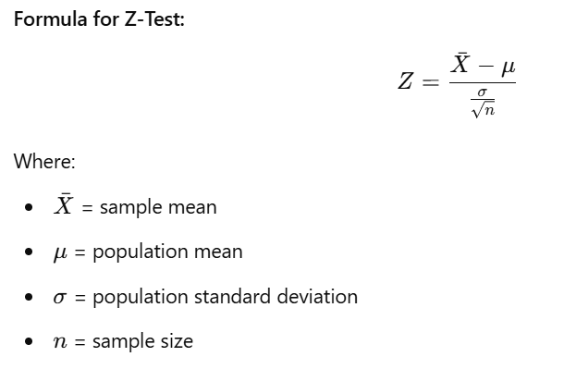

**Example:**

Suppose you have a population of students with a mean test score of 80, and the standard deviation of the scores is 10. You take a random sample of 50 students, and the mean score is 82. You want to test if the sample mean is significantly different from the population mean.

1. **Null Hypothesis (H₀)**: The sample mean is equal to the population mean (no difference).
2. **Alternative Hypothesis (H₁)**: The sample mean is not equal to the population mean (there is a difference).
3. **Z-test**:

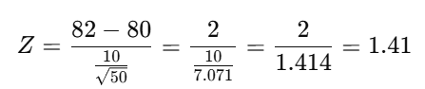

You would then look up the Z value in a standard normal table (Z-table) to find the p-value. If the p-value is less than the significance level (α), you reject the null hypothesis.

**T-Test**

The **t-test** is used when:

* The sample size is small (n≤30n \leq 30n≤30).
* The population standard deviation is unknown.
* The data follows a normal distribution.

There are three main types of t-tests:

1. **One-Sample T-Test**: Tests whether the sample mean differs from a known population mean.
2. **Two-Sample T-Test (Independent T-Test)**: Compares the means of two independent groups.
3. **Paired T-Test**: Compares means from the same group at different times (e.g., before and after treatment).

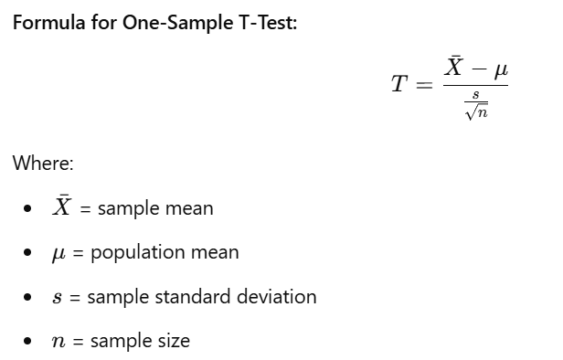

**Example (One-Sample T-Test):**

Suppose a teacher claims that the average score of her class is 75. You take a random sample of 20 students and find their mean score is 70 with a sample standard deviation of 10. You want to test if the actual mean score is significantly different from 75.

1. **Null Hypothesis (H₀)**: The sample mean is equal to 75.
2. **Alternative Hypothesis (H₁)**: The sample mean is not equal to 75.
3. **T-test**

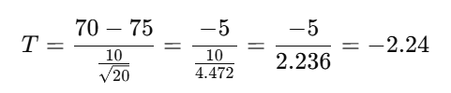

You would compare the calculated t-value to the critical t-value from a t-distribution table based on degrees of freedom (df=n−1) and the significance level (α). If the calculated t-value is more extreme than the critical value, you reject the null hypothesis.

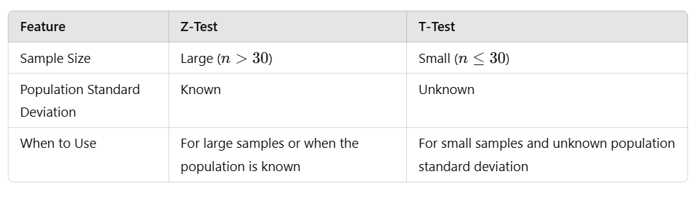

**Visual Comparison:**

* **Z-Test**: Looks at the normal distribution.
* **T-Test**: Uses the t-distribution, which is wider and has fatter tails than the normal distribution. As sample size increases, the t-distribution approaches the normal distribution.

**Example: Two-Sample T-Test**

You have two groups of students. Group A (10 students) and Group B (12 students) take different teaching methods. You want to know if the teaching methods resulted in different average scores.

1. **Null Hypothesis (H₀)**: The means of the two groups are equal.
2. **Alternative Hypothesis (H₁)**: The means of the two groups are different.
3. **Two-Sample T-Test**: You would calculate the t-value comparing the means of the two groups and check it against a t-distribution table to decide whether to reject or fail to reject the null hypothesis.

**Conclusion:**

* **Z-tests** are preferred for large samples and known population standard deviations.
* **T-tests** are used for small samples and unknown population standard deviations.

**Z-Test Practical Example**

**Scenario**: A factory claims the average weight of a product is 100 grams. You take a sample of 50 products and find the sample mean weight is 98 grams, with a population standard deviation of 5 grams. You want to test whether the average product weight is significantly different from 100 grams.

**Step 1: Set up the Hypotheses**

* **Null Hypothesis (H₀)**: The true mean weight is 100 grams.
* **Alternative Hypothesis (H₁)**: The true mean weight is not equal to 100 grams.

This is a **two-tailed test** because we're checking for a difference, not just an increase or decrease.

**Step 2: Choose a Significance Level (α)**

Let’s use α = 0.05 (a common choice).

**Step 3: Calculate the Z-Statistic**

Use the z-test formula:

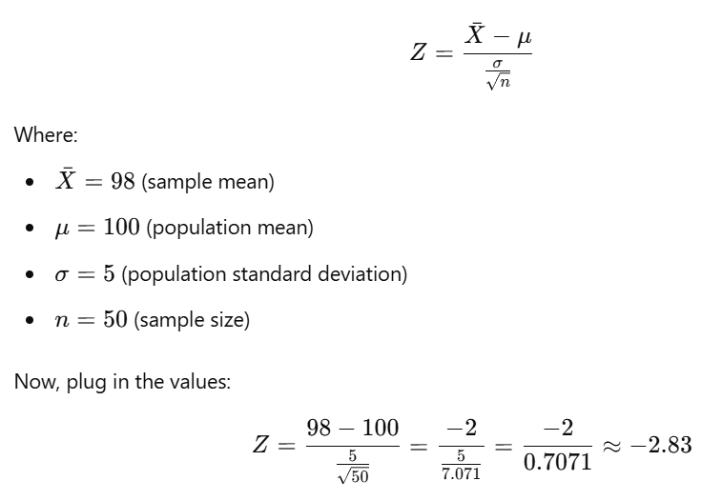

**Step 4: Find the P-Value**

Using a Z-table (or statistical software), find the p-value corresponding to Z= −2.83.

The p-value for Z=−2.83 is approximately **0.0046**.

**Step 5: Compare the P-Value to α**

Since the p-value (0.0046) is less than α (0.05), we **reject the null hypothesis**. This means the average product weight is significantly different from 100 grams.

**T-Test Practical Example**

**Scenario**: A teacher claims that the average test score in her class is 70. You take a sample of 15 students, and their average score is 65 with a sample standard deviation of 8. You want to test if the class average is significantly different from 70.

**Step 1: Set up the Hypotheses**

* **Null Hypothesis (H₀)**: The true mean score is 70.
* **Alternative Hypothesis (H₁)**: The true mean score is not equal to 70.

Again, this is a **two-tailed test**.

**Step 2: Choose a Significance Level (α)**

Let’s use α = 0.05.

**Step 3: Calculate the T-Statistic**

Use the t-test formula:

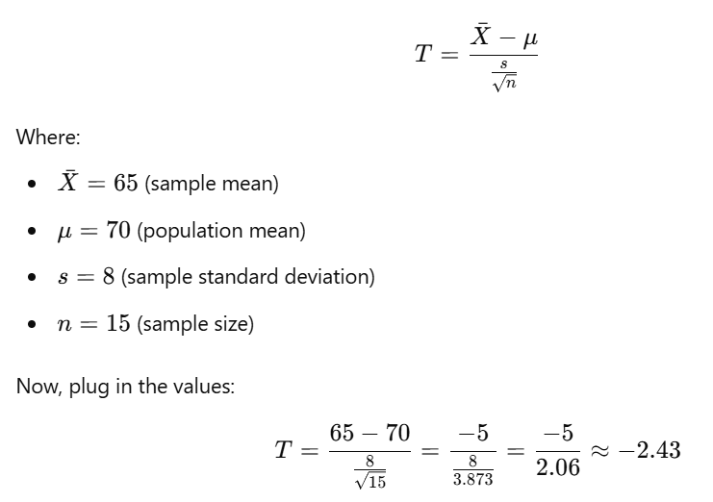

**Step 4: Find the P-Value**

The degrees of freedom (df) for this t-test is n−1=15−1=14

Using a t-distribution table (or statistical software), find the p-value for T= −2.43 with 14 degrees of freedom. The p-value is approximately **0.029**.

**Step 5: Compare the P-Value to α**

Since the p-value (0.029) is less than α (0.05), we **reject the null hypothesis**. This means the average test score is significantly different from 70.

**Summary of Steps:**

1. **Formulate Hypotheses**: Define your null and alternative hypotheses.
2. **Choose a Significance Level (α)**: Common values are 0.05 or 0.01.
3. **Calculate the Test Statistic**:
   * Use the **z-test** if the sample size is large (n>30) and the population standard deviation is known.
   * Use the **t-test** if the sample size is small (n≤30) and the population standard deviation is unknown.
4. **Find the P-Value**: Use a Z-table or T-table (or statistical software) to find the p-value based on your test statistic.
5. **Make a Decision**: Compare the p-value to α. If the p-value is less than α, reject the null hypothesis.

**Scenario 1: Z-Test Example**

You are a researcher studying the IQ of a population. The average IQ score is known to be 100, with a population standard deviation of 15. You take a random sample of 40 people, and their average IQ score is 105. You want to test whether the average IQ in your sample is significantly different from the population average.

* **Null Hypothesis (H₀)**: The mean IQ score is 100.
* **Alternative Hypothesis (H₁)**: The mean IQ score is not 100.
* **Significance level (α)**: 0.05

**Scenario 2: T-Test Example**

You are a teacher who believes your students are performing worse than the national average on a math test. The national average score is 75. You take a sample of 20 students from your class, and their average score is 72, with a sample standard deviation of 6. You want to test if the average score of your students is lower than the national average.

* **Null Hypothesis (H₀)**: The mean score of your students is 75.
* **Alternative Hypothesis (H₁)**: The mean score of your students is less than 75.
* **Significance level (α)**: 0.05

**Instructions:**

1. Choose **Scenario 1 (z-test)** or **Scenario 2 (t-test)**.
2. Try to calculate the test statistic (Z or T).
3. Find the p-value using a Z-table (for z-test) or T-table (for t-test).
4. Compare the p-value to the significance level (α) and decide whether to reject or fail to reject the null hypothesis.

**Scenario 1 Recap:**

* **Population Mean (μ)**: 100
* **Population Standard Deviation (σ)**: 15
* **Sample Size (n)**: 40
* **Sample Mean (X̄)**: 105
* **Significance Level (α)**: 0.05

**Step 1: State the Hypotheses**

* **Null Hypothesis (H₀)**: The mean IQ score is 100.

H₀ ​: μ=100

* **Alternative Hypothesis (H₁)**: The mean IQ score is not 100.

H₁ : μ≠100

This is a **two-tailed test** because we are checking if the sample mean is **different** from the population mean.

**Step 2: Calculate the Z-Statistic**

The formula for the Z-test is:

So, the **Z-score** is approximately **2.11**.

**Step 3: Find the P-Value**

Now that we have the Z-score, we can find the corresponding p-value using a Z-table (or software).

For a Z-score of 2.11 (two-tailed test):

* The p-value for a Z-score of 2.11 is approximately **0.035** for each tail.
* Since this is a two-tailed test, we multiply by 2:

P-value = 2×0.035 = 0.07

**Step 4: Compare the P-Value to α**

* **P-value**: 0.07
* **Significance level (α)**: 0.05

Since the p-value (0.07) is **greater** than the significance level (0.05), we **fail to reject the null hypothesis**. This means that the sample mean is **not significantly different** from the population mean of 100.

**Conclusion:**

There is no strong evidence to suggest that the average IQ of your sample is significantly different from the population average of 100.

Let's modify **Scenario 1** for a **t-test**. The t-test is used when the population standard deviation is **unknown** and the sample size is relatively small (typically n≤30).

**T-Test Scenario:**

You don’t know the population standard deviation, so you’ll use the sample standard deviation instead. Let's adjust the scenario:

* **Population Mean (μ)**: 100
* **Sample Size (n)**: 20
* **Sample Mean (X̄)**: 105
* **Sample Standard Deviation (s)**: 18
* **Significance Level (α)**: 0.05

**Step 1: State the Hypotheses**

* **Null Hypothesis (H₀)**: The mean IQ score is 100.

H₀ : μ=100

* **Alternative Hypothesis (H₁)**: The mean IQ score is not 100.

H₁ : μ≠100

This is again a **two-tailed test**.

**Step 2: Calculate the T-Statistic**

The formula for the t-test is:

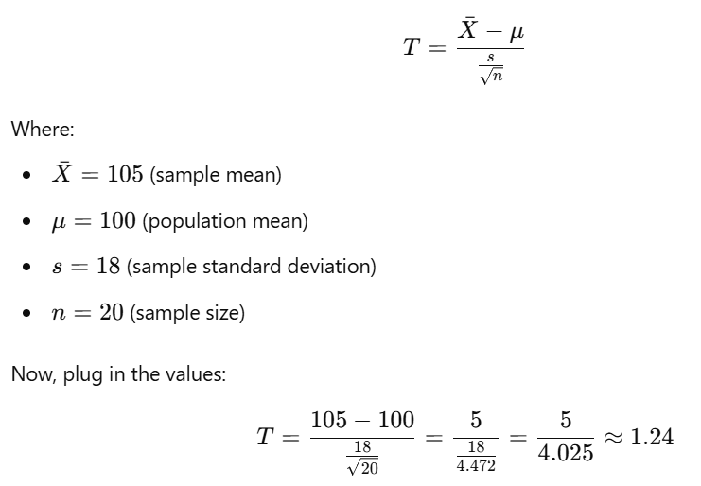

So, the **T-score** is approximately **1.24**.

**Step 3: Find the P-Value**

Now that we have the T-score, we need to find the p-value using a t-distribution table (or statistical software). For a **two-tailed test** with n−1=20−1=19 degrees of freedom (df):

Using a **T-table** or software:

* The p-value corresponding to a T-score of **1.24** with **19 degrees of freedom** is approximately **0.23** (for each tail).
* Since this is a **two-tailed test**, we multiply the p-value by 2:

P-value = 2×0.23=0.46

**Step 4: Compare the P-Value to α**

* **P-value**: 0.46
* **Significance level (α)**: 0.05

Since the p-value (0.46) is **much greater** than the significance level (0.05), we **fail to reject the null hypothesis**. This means there is **no significant evidence** to suggest that the sample mean is different from the population mean of 100.

**Conclusion:**

There is not enough evidence to suggest that the average IQ in the sample is significantly different from 100 when using a **t-test**.

Hypothesis testing is a crucial tool in **data science** and **machine learning** to make data-driven decisions by evaluating whether the evidence in a dataset supports a specific claim. It helps in validating assumptions, evaluating model performance, and comparing different models or methods. Here’s how and when hypothesis testing is used in these fields:

**When to Use Hypothesis Testing in Data Science and Machine Learning**

1. **Evaluating Model Performance**:
   * After training machine learning models, you often want to compare their performance. Hypothesis testing helps in determining whether the difference in performance between two models (e.g., accuracy, precision) is statistically significant or just due to random variation in the data.
   * Example: Testing whether a new model’s accuracy is significantly better than the baseline model.
2. **Feature Selection**:
   * Hypothesis testing helps determine whether certain features (predictor variables) are significantly associated with the target variable.
   * Example: In regression, you use hypothesis tests to check if a feature has a statistically significant effect on the output, helping in feature selection.
3. **A/B Testing (Experimentation)**:
   * A/B testing is a direct application of hypothesis testing to compare two versions of a product, website, or system to see if changes lead to statistically significant improvements.
   * Example: Comparing two versions of a webpage to see if a new design leads to a higher conversion rate.
4. **Checking Assumptions**:
   * Many machine learning algorithms (such as linear regression) rely on certain assumptions about the data (like normality, homoscedasticity, etc.). Hypothesis testing helps check if these assumptions hold.
   * Example: Using a normality test to check if residuals from a regression model are normally distributed.
5. **Detecting Outliers and Anomalies**:
   * Hypothesis testing can be used to detect whether certain data points are outliers or anomalies by testing whether they come from the same distribution as the rest of the data.
   * Example: Testing if an observed high transaction value in an e-commerce dataset is an anomaly.

**How to Use Hypothesis Testing in Data Science and Machine Learning**

1. **Define the Problem**:
   * Clearly state the null hypothesis H0​ (no effect, no difference) and the alternative hypothesis H1​ (there is an effect, or a difference).
   * Example: You want to compare the accuracy of two classification models.
     + H0 ​: The accuracies of both models are the same.
     + H1​ : The accuracies of the models are different.
2. **Select the Test**:
   * Choose the appropriate statistical test based on the type of data and the hypothesis. Some common tests include:
     + **t-test**: Comparing means of two groups (e.g., accuracy or loss between two models).
     + **z-test**: For larger sample sizes or known population variance.
     + **Chi-square test**: For categorical data (e.g., comparing distributions).
     + **ANOVA**: Comparing means across multiple groups or models.
3. **Collect and Prepare Data**:
   * Gather the relevant data and ensure it is cleaned and preprocessed. Depending on the test, this could be performance metrics, features, or experiment results.
4. **Perform the Test**:
   * Use statistical libraries such as SciPy in Python to perform the hypothesis test and calculate the **p-value**.
   * The p-value will indicate whether the null hypothesis should be rejected or not.
5. **Make a Decision**:
   * Based on the p-value, you can:
     + **Reject H0​**: If the p-value is less than the significance level α\alphaα (e.g., 0.05), there is enough evidence to suggest a significant effect.
     + **Fail to reject H0​**: If the p-value is greater than α\alphaα, there is not enough evidence to support the alternative hypothesis.
6. **Interpret Results**:
   * After the test, interpret the result in the context of the problem:
     + **Statistical Significance**: If the test rejects the null hypothesis, it implies that the observed effect or difference is unlikely due to chance.
     + **Practical Significance**: Even if a result is statistically significant, consider whether the effect size is meaningful in a practical sense (e.g., a very small improvement in accuracy may not be useful).

**Examples in Data Science and Machine Learning**

1. **Model Comparison**:
   * You have two models: a logistic regression and a decision tree classifier. You want to test if the **mean accuracy** of the decision tree is significantly higher than that of logistic regression.
   * **Hypothesis**:
     + H0: There is no difference in accuracy between the two models.
     + H1: The accuracy of the decision tree is significantly higher than the logistic regression model.
   * **Test**: Perform a t-test on the accuracy scores from cross-validation.
2. **Feature Importance in Linear Regression**:
   * You build a regression model and want to test if the coefficient of a feature (say, advertising spend) is significantly different from zero.
   * **Hypothesis**:
     + H0H_0H0​: The coefficient of advertising spend is 0 (no impact).
     + H1H_1H1​: The coefficient of advertising spend is not 0 (has an impact).
   * **Test**: Use a t-test to check if the feature is statistically significant.
3. **A/B Testing for Website Conversions**:
   * A company runs an A/B test to check if a new button design leads to higher conversion rates.
   * **Hypothesis**:
     + H0​: The conversion rate with the new button is the same as with the old button.
     + H1: The conversion rate with the new button is different from the old button.
   * **Test**: Perform a z-test on the conversion rates from the two groups.

Let's go through a **practical example** of how hypothesis testing can be used in **machine learning** for **comparing model performance**. We will:

1. Train two machine learning models.
2. Compare their performance (accuracy) using a **hypothesis test** to determine if one model performs significantly better than the other.

We'll use a **t-test** for this comparison, as it's a common statistical test used when comparing the means of two groups (in this case, the accuracies of the models).

**Example Scenario: Comparing Two Classifier Models**

Suppose we have a dataset and we train two classifiers: a **Logistic Regression** model and a **Decision Tree** model. We want to test if the Logistic Regression model performs significantly better than the Decision Tree model in terms of accuracy.

**Steps:**

1. **Set Up Hypotheses**:
   * **Null Hypothesis (H₀)**: There is no significant difference between the accuracies of the two models.
   * **Alternative Hypothesis (H₁)**: The Logistic Regression model performs significantly better than the Decision Tree model.
2. **Data**: We will use a sample dataset (e.g., the Iris dataset) to train the models.
3. **t-test**: We'll perform a paired t-test to compare the accuracies of the models over multiple cross-validation folds.

# Import necessary libraries

from sklearn.datasets import load_iris

from sklearn.model_selection import cross_val_score

from sklearn.linear_model import LogisticRegression

from sklearn.tree import DecisionTreeClassifier

from scipy import stats

import numpy as np

# Load the Iris dataset

data = load_iris()

X = data.data

y = data.target

# Initialize the models

log_reg = LogisticRegression(max_iter=200)

decision_tree = DecisionTreeClassifier()

# Perform cross-validation and collect accuracy scores

log_reg_scores = cross_val_score(log_reg, X, y, cv=10) # 10-fold cross-validation

decision_tree_scores = cross_val_score(decision_tree, X, y, cv=10)

# Display the accuracy scores for each model

print("Logistic Regression accuracies:", log_reg_scores)

print("Decision Tree accuracies:", decision_tree_scores)

# Step 4: Perform a paired t-test on the accuracy scores

t_stat, p_value = stats.ttest_rel(log_reg_scores, decision_tree_scores)

# Display the results of the t-test

print(f"t-statistic: {t_stat}")

print(f"p-value: {p_value}")

# Step 5: Conclusion based on p-value

alpha = 0.05 # Significance level

if p_value < alpha:

print("Reject the null hypothesis. Logistic Regression performs significantly better.")

else:

print("Fail to reject the null hypothesis. No significant difference in performance.")

**Three types of t-test**

**1. One-Sample t-test**

The **one-sample t-test** is used to determine whether the mean of a single sample is significantly different from a known or hypothesized population mean.

**Example:**

You are a data analyst at a coffee company. You suspect that the average amount of coffee in a cup is **less than the standard 12 ounces**. You take a sample of 10 cups and measure the amount of coffee in each. Now you want to test whether the mean amount of coffee in the sample is significantly different from 12 ounces.

* **Null Hypothesis (H0​)**: The mean amount of coffee is equal to 12 ounces (μ=12).
* **Alternative Hypothesis (H1​)**: The mean amount of coffee is not equal to 12 ounces (μ≠12).

from scipy import stats

import numpy as np

# Sample data (amount of coffee in ounces)

coffee_sample = np.array([11.8, 12.3, 12.1, 11.9, 11.7, 12.4, 12.0, 11.6, 12.2, 12.1])

# Hypothesized population mean

mu = 12

# Perform one-sample t-test

t_stat, p_value = stats.ttest_1samp(coffee_sample, mu)

print(f"t-statistic: {t_stat}, p-value: {p_value}")

**2. Independent Two-Sample t-test**

The **independent two-sample t-test** (or simply **two-sample t-test**) is used to determine whether the means of two **independent groups** are significantly different from each other. This test is often used in A/B testing or comparing results between two different groups.

**Example:**

Suppose you're comparing the test scores of students from two different schools. You want to determine if the average test score from **School A** is significantly different from **School B**.

* **Null Hypothesis (H0​)**: The mean test scores of both schools are equal (μA=μB​).
* **Alternative Hypothesis (H1​)**: The mean test scores of the two schools are different (μA≠μB​).

# Test scores from two different schools

school_A_scores = np.array([85, 88, 90, 78, 93, 80, 87, 91])

school_B_scores = np.array([82, 79, 85, 75, 80, 77, 84, 81])

# Perform independent two-sample t-test

t_stat, p_value = stats.ttest_ind(school_A_scores, school_B_scores)

print(f"t-statistic: {t_stat}, p-value: {p_value}")

In this case, if the p-value is small enough, you can conclude that there is a statistically significant difference between the two schools' test scores.

**3. Paired t-test (Dependent t-test)**

The **paired t-test** is used when you are comparing **two sets of observations** from the same group or related groups. This test is often used in **before-and-after studies** or experiments where you measure the same individuals before and after a treatment.

**Example:**

A researcher wants to test the effectiveness of a new diet plan. They measure the **weights of 10 individuals before and after** following the diet. The goal is to determine if the diet plan led to a significant change in weight.

* **Null Hypothesis (H0​)**: There is no difference in weight before and after the diet (μbefore=μafter​).
* **Alternative Hypothesis (H1​)**: There is a difference in weight before and after the diet (μbefore≠μafter​).

# Weights of individuals before and after the diet

weights_before = np.array([180, 165, 170, 155, 160, 175, 150, 185, 190, 172])

weights_after = np.array([175, 160, 168, 150, 158, 170, 148, 180, 185, 170])

# Perform paired t-test

t_stat, p_value = stats.ttest_rel(weights_before, weights_after)

print(f"t-statistic: {t_stat}, p-value: {p_value}")

If the p-value is less than your chosen significance level (e.g., α=0.05\alpha = 0.05α=0.05), you can reject the null hypothesis, concluding that the diet caused a significant change in weight.

**Summary of the Three Types of t-tests:**

| **Type of t-test** | **When to Use** | **Example** |
| --- | --- | --- |
| **One-Sample t-test** | To compare the sample mean to a known population mean. | Testing if the average coffee amount is 12 ounces. |
| **Independent Two-Sample t-test** | To compare the means of two independent groups. | Comparing test scores of students from two schools. |
| **Paired t-test** | To compare two sets of related observations (same group). | Comparing weights before and after a diet plan. |

**When to Use Each Test:**

* **One-Sample t-test**: When you have one sample and want to test if the mean of that sample is different from a known value.
* **Two-Sample t-test**: When you have two independent samples and want to test if their means are significantly different.
* **Paired t-test**: When you have two related samples (e.g., the same group measured twice) and want to test if there is a significant difference in the means.

Let's dive deeper into each type of **t-test** with more detailed examples and explanations. We'll cover more advanced scenarios where these t-tests are applied in real-world data analysis situations.

**1. One-Sample t-test: In-Depth Example**

**Scenario: Testing Average Customer Satisfaction**

Imagine you're working as a data analyst for a retail company, and you want to check if the **average customer satisfaction rating** is **different from the target score of 4.5 out of 5**. You conduct a survey and gather a random sample of 15 customers' satisfaction ratings.

* **Null Hypothesis (H0​)**: The mean customer satisfaction score is equal to 4.5.
* **Alternative Hypothesis (H1​)**: The mean customer satisfaction score is not equal to 4.5.

Here, the company is interested in whether the satisfaction rating is **different** from the target, not specifically higher or lower. This is a **two-tailed test**.

import numpy as np

from scipy import stats

# Sample customer satisfaction ratings (out of 5)

customer_ratings = np.array([4.2, 4.8, 4.6, 4.5, 4.7, 4.3, 4.4, 4.9, 4.5, 4.6, 4.3, 4.4, 4.8, 4.7, 4.6])

# Hypothesized population mean (target satisfaction score)

target_mean = 4.5

# Perform one-sample t-test

t_stat, p_value = stats.ttest_1samp(customer_ratings, target_mean)

print(f"t-statistic: {t_stat}, p-value: {p_value}")

# Significance level

alpha = 0.05

if p_value < alpha:

print("Reject the null hypothesis: The average satisfaction rating is significantly different from 4.5.")

else:

print("Fail to reject the null hypothesis: No significant difference in the average satisfaction rating.")

**Interpretation:**

* If the **p-value** is less than 0.050.050.05, it means the average satisfaction score is significantly different from 4.5.
* If the **p-value** is greater than 0.050.050.05, you **fail to reject the null hypothesis**, meaning there's no significant difference from 4.5.

**2. Independent Two-Sample t-test: In-Depth Example**

**Scenario: Comparing Sales Between Two Marketing Strategies**

You want to compare the **effectiveness of two marketing strategies**. You've applied **Strategy A** to 10 regions and **Strategy B** to another 10 regions. After the campaign, you collect the **sales data** from each region.

* **Null Hypothesis (H0​)**: The mean sales from Strategy A and Strategy B are equal.
* **Alternative Hypothesis (H1​)**: The mean sales from Strategy A are different from Strategy B.

This is a **two-tailed independent t-test** because we're checking if the sales differ between the two groups, without specifying if one is greater or less.

# Sales data (in thousands) from two marketing strategies

strategy_A_sales = np.array([10.5, 9.8, 10.1, 11.3, 9.9, 10.2, 11.1, 9.7, 10.4, 10.6])

strategy_B_sales = np.array([9.5, 9.7, 9.6, 10.0, 9.9, 10.2, 9.4, 9.8, 10.1, 9.6])

# Perform independent two-sample t-test

t_stat, p_value = stats.ttest_ind(strategy_A_sales, strategy_B_sales)

print(f"t-statistic: {t_stat}, p-value: {p_value}")

# Significance level

alpha = 0.05

if p_value < alpha:

print("Reject the null hypothesis: The sales from Strategy A and Strategy B are significantly different.")

else:

print("Fail to reject the null hypothesis: No significant difference in the sales.")

**Interpretation:**

* If the **p-value** is small, say less than 0.050.050.05, it means there is a significant difference between the sales performance of Strategy A and Strategy B.
* If the p-value is higher than 0.050.050.05, there is **no evidence** to suggest a significant difference in sales between the two strategies.

**3. Paired t-test (Dependent t-test): In-Depth Example**

**Scenario: Testing the Effectiveness of a New Study Technique**

You want to test whether a **new study technique** improves students' exam scores. You take a sample of 12 students and record their scores **before** and **after** they adopt the new technique. Now, you want to check if there's a significant improvement in their scores.

* **Null Hypothesis (H0)**: There is no difference in exam scores before and after the new study technique.
* **Alternative Hypothesis (H1​)**: The exam scores after the study technique are higher than before.

Since this involves comparing **two related sets of scores** (before and after), it’s a **paired t-test**. In this case, you’re particularly interested in whether the scores **increase**, so it will be a **one-tailed test**.

# Exam scores of students before and after using a new study technique

scores_before = np.array([75, 80, 82, 70, 78, 85, 77, 69, 74, 79, 81, 73])

scores_after = np.array([80, 85, 86, 74, 82, 88, 83, 72, 78, 85, 87, 77])

# Perform paired t-test (one-tailed)

t_stat, p_value = stats.ttest_rel(scores_after, scores_before)

# Since it's a one-tailed test, divide the p-value by 2

p_value /= 2

print(f"t-statistic: {t_stat}, p-value: {p_value}")

# Significance level

alpha = 0.05

if t_stat > 0 and p_value < alpha: # Check for one-tailed condition

print("Reject the null hypothesis: The new study technique significantly improved exam scores.")

else:

print("Fail to reject the null hypothesis: No significant improvement in exam scores.")

**Interpretation:**

* If the **p-value** is less than 0.050.050.05 and the **t-statistic is positive**, you can reject the null hypothesis and conclude that the new study technique significantly improved exam scores.
* If the **p-value** is greater than 0.050.050.05, you **fail to reject the null hypothesis**, indicating that the study technique did not significantly improve the scores.

**Key Insights and Use Cases in Real World:**

* **One-Sample t-test**: Use when you want to compare the sample mean to a known or standard value (e.g., testing if a production line is hitting a target output).
* **Independent Two-Sample t-test**: Use when comparing two **independent** groups to check if there is a significant difference between them (e.g., comparing the effectiveness of two marketing strategies or models).
* **Paired t-test**: Use when you want to compare two related samples (e.g., before and after tests, or measuring a treatment’s effect on the same subjects).

**A/B Testing**

A/B testing, also known as **split testing**, is a method used in data science and business analytics to compare two versions of something (like a webpage, a product design, or a marketing campaign) to determine which one performs better. It is widely used in fields like marketing, web development, and product design.

In A/B testing, you:

* Split your audience or users into **two groups**: Group A (control) and Group B (variant).
* Show each group a different version (Version A and Version B).
* Measure the outcome to see which version leads to better results.

**How A/B Testing Works:**

1. **Formulate a Hypothesis**: You need to decide what you want to test. For example, "Will changing the color of the 'Buy Now' button from green to red increase the purchase rate?"
2. **Create Variants**:
   * **A**: The original version (control group).
   * **B**: The modified version (variant group).
3. **Random Assignment**: Randomly assign users to each group so that any difference in results can be attributed to the change, not to the selection of participants.
4. **Collect Data**: Track the key performance indicators (KPIs) for both groups. For example, conversion rate, click-through rate, or sales.
5. **Analyze the Results**: Use statistical tests like the **t-test** or **Z-test** to determine whether the difference between the two groups is statistically significant.

**Example 1: A/B Testing in Web Design**

**Scenario: Changing the Color of a "Sign Up" Button**

A company wants to test if changing the "Sign Up" button color from blue to orange improves the number of sign-ups on their website.

* **Hypothesis**: Changing the button color will increase sign-ups.
* **Control Group (A)**: Users see the **blue** button.
* **Test Group (B)**: Users see the **orange** button.

The key metric to measure here is the **conversion rate**, which is the percentage of users who clicked the "Sign Up" button.

**Steps:**

1. **Assign Users Randomly**: Assign half of the users to Group A (blue button) and half to Group B (orange button).
2. **Collect Data**: After a set period (e.g., one week), you gather the data on how many users from each group clicked the button.
3. **Perform a t-test**: Check if the difference in conversion rates between Group A and Group B is statistically significant.

**Code Example (A/B Testing Simulation):**

Let’s simulate this with some fake data using a **t-test** to see if changing the button color led to a statistically significant increase in clicks.

import numpy as np

from scipy import stats

# Simulated data: number of users and number of clicks in each group

# Group A (blue button)

group_A_clicks = np.array([1 if np.random.rand() < 0.10 else 0 for _ in range(1000)]) # 10% click rate

# Group B (orange button)

group_B_clicks = np.array([1 if np.random.rand() < 0.12 else 0 for _ in range(1000)]) # 12% click rate

# Perform independent two-sample t-test

t_stat, p_value = stats.ttest_ind(group_A_clicks, group_B_clicks)

print(f"t-statistic: {t_stat}, p-value: {p_value}")

# Significance level

alpha = 0.05

if p_value < alpha:

print("Reject the null hypothesis: The button color change significantly increased sign-ups.")

else:

print("Fail to reject the null hypothesis: The button color change did not significantly affect sign-ups.")

**Example 2: A/B Testing in Email Campaigns**

**Scenario: Testing Subject Line Effectiveness**

A company wants to know if changing the subject line of an email campaign will lead to a higher open rate.

* **Hypothesis**: Changing the subject line will increase the email open rate.
* **Control Group (A)**: Users receive an email with the subject line **"Join Now for Exclusive Offers!"**.
* **Test Group (B)**: Users receive an email with the subject line **"Get 50% Off Today Only!"**.

Here, the key metric is the **open rate**.

**Steps:**

1. **Assign Users**: Randomly split the email recipients into two groups.
2. **Collect Data**: Measure the percentage of users who opened the email in both groups.
3. **Statistical Test**: Use a **Z-test** for proportions since we are comparing rates (percentage of opens) between two groups.

# Simulated data: number of emails sent and opened in each group

n_A = 1000 # Emails sent to group A

n_B = 1000 # Emails sent to group B

opens_A = np.random.binomial(n_A, 0.15) # 15% open rate for group A

opens_B = np.random.binomial(n_B, 0.18) # 18% open rate for group B

# Conversion rates

conversion_A = opens_A / n_A

conversion_B = opens_B / n_B

# Perform a Z-test for proportions

from statsmodels.stats.proportion import proportions_ztest

# Test the difference between two proportions (open rates)

count = np.array([opens_A, opens_B])

nobs = np.array([n_A, n_B])

z_stat, p_value = proportions_ztest(count, nobs)

print(f"z-statistic: {z_stat}, p-value: {p_value}")

if p_value < alpha:

print("Reject the null hypothesis: The subject line change significantly increased the open rate.")

else:

print("Fail to reject the null hypothesis: The subject line change did not significantly affect the open rate.")

**When to Use A/B Testing in Data Science:**

A/B testing is frequently used in:

1. **Website Optimization**: Testing different layouts, call-to-action buttons, or other design elements to improve engagement or conversion rates.
2. **Marketing Campaigns**: Comparing different ad versions to see which generates more clicks or leads.
3. **Product Features**: Testing new features or versions of a product to see if they increase user engagement or satisfaction.

**Key Considerations:**

* **Sample Size**: You need a large enough sample size for the results to be reliable. Too few users, and you might not detect a real difference.
* **Significance Levels**: Commonly, the significance level (α\alphaα) is set at **0.05** (5%). If the p-value is less than this, you conclude that the observed effect is statistically significant.
* **Testing Duration**: Run the test long enough to capture a representative sample of users, especially if you have seasonal variations in traffic or behavior.

**Chi-Square Test**

The **Chi-Square test** is a statistical test used to determine whether there is a significant association between two categorical variables. It is used when you want to see if the observed frequencies in your data differ significantly from expected frequencies under the null hypothesis.

There are two main types of chi-square tests:

1. **Chi-Square Goodness of Fit Test**: This test determines if a sample data matches a population with a specific distribution.
2. **Chi-Square Test of Independence**: This test checks whether two categorical variables are independent of each other.

**Key Concepts:**

* **Observed Frequencies**: The actual data counts you've collected.
* **Expected Frequencies**: What you would expect the counts to be if there were no relationship between the variables.

**When to Use a Chi-Square Test:**

* You have two categorical variables.
* Your data is in the form of frequencies (counts).
* You want to test if the distribution of these frequencies is different from what you'd expect.

**Chi-Square Test Formula:**

For both types of Chi-Square tests, the test statistic is calculated using the formula:

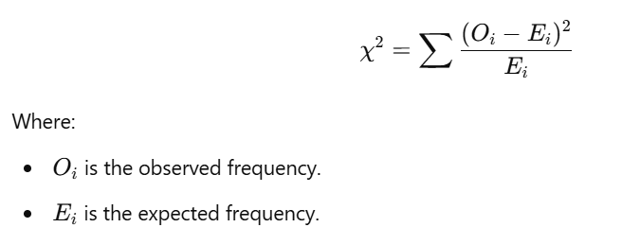

**Chi-Square Test of Independence Example**

**Scenario: Testing the Relationship Between Gender and Preference for a Product**

You conducted a survey to find out if there is a relationship between **gender** and **preference for a new product** (liked or didn't like). Here's the observed data:

| **Gender** | **Liked Product** | **Didn't Like Product** | **Total** |
| --- | --- | --- | --- |
| Male | 60 | 40 | 100 |
| Female | 70 | 30 | 100 |
| Total | 130 | 70 | 200 |

You want to know if there is a significant association between **gender** and **preference**.

**Steps for Chi-Square Test of Independence:**

1. **Set Hypotheses**:
   * **Null Hypothesis (H₀)**: Gender and preference for the product are independent (no association).
   * **Alternative Hypothesis (H₁)**: Gender and preference for the product are dependent (there is an association).
2. **Calculate Expected Frequencies**: Expected frequency for each cell is calculated as:

Do this for all cells to get the expected counts.

1. **Perform the Chi-Square Test**:

Use the formula above to calculate the chi-square test statistic.

1. **Compare p-value**: Check the p-value from the chi-square distribution table (or use a software tool to compute it) to decide whether to reject or fail to reject the null hypothesis.

**Python Code Example for Chi-Square Test of Independence:**

Let's calculate the Chi-Square test using Python and the observed data.

import numpy as np

from scipy.stats import chi2_contingency

# Observed frequencies (contingency table)

observed = np.array([[60, 40], # Males

[70, 30]]) # Females

# Perform the Chi-Square test of independence

chi2_stat, p_value, dof, expected = chi2_contingency(observed)

print(f"Chi-Square Statistic: {chi2_stat}")

print(f"p-value: {p_value}")

print(f"Degrees of Freedom: {dof}")

print("Expected Frequencies: \n", expected)

# Significance level

alpha = 0.05

if p_value < alpha:

print("Reject the null hypothesis: There is a significant relationship between gender and product preference.")

else:

print("Fail to reject the null hypothesis: No significant relationship between gender and product preference.")

**Output Interpretation:**

* **Chi-Square Statistic**: The larger this value, the greater the difference between observed and expected frequencies.
* **p-value**: If this is smaller than the significance level (usually 0.05), you reject the null hypothesis and conclude that there is an association between the variables.

**Chi-Square Goodness of Fit Test Example**

**Scenario: Checking if a Die is Fair**

You roll a die 60 times and observe the following outcomes:

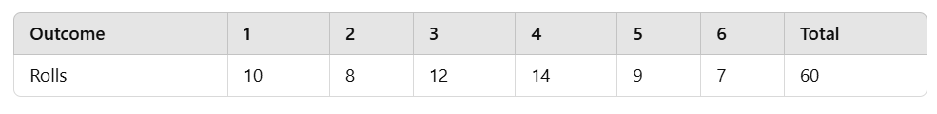

You want to check if the die is fair, i.e., if each side has an equal probability of being rolled.

**Steps for Goodness of Fit Test:**

1. **Set Hypotheses**:
   * **Null Hypothesis (H₀)**: The die is fair (all sides have equal probability).
   * **Alternative Hypothesis (H₁)**: The die is not fair (not all sides have equal probability).
2. **Expected Frequencies**: If the die is fair, each side should come up with an equal frequency, which is 60/6 = 10.
3. **Perform the Chi-Square Test**: Compare the observed frequencies with the expected frequencies.

**Python Code Example for Chi-Square Goodness of Fit:**

# Observed frequencies

observed_rolls = np.array([10, 8, 12, 14, 9, 7])

# Expected frequencies for a fair die

expected_rolls = np.array([10, 10, 10, 10, 10, 10])

# Perform the Chi-Square Goodness of Fit Test

chi2_stat, p_value = stats.chisquare(observed_rolls, f_exp=expected_rolls)

print(f"Chi-Square Statistic: {chi2_stat}")

print(f"p-value: {p_value}")

if p_value < alpha:

print("Reject the null hypothesis: The die is not fair.")

else:

print("Fail to reject the null hypothesis: The die is fair.")

**When to Use the Chi-Square Test in Data Science:**

1. **Categorical Data Analysis**: Use chi-square tests when working with categorical variables like gender, education level, or customer preferences.
2. **Market Research**: Determine if two marketing strategies are equally effective in different regions.
3. **Customer Segmentation**: Test if there is an association between customer segments (e.g., age group, income level) and purchasing behavior.
4. **Biological and Medical Research**: Use the test to see if there is a relationship between treatment type and patient outcomes.

**Key Considerations:**

* **Sample Size**: Chi-square tests require a large enough sample size. Small samples might not provide reliable results.
* **Cell Frequency**: For the test to be valid, the expected frequency in each cell should ideally be at least 5.

**ANOVA (Analysis of Variance)**

**ANOVA** (Analysis of Variance) is a statistical technique used to compare the means of three or more groups to see if there is a statistically significant difference between them. ANOVA helps in understanding whether the observed differences among group means are due to true differences in the population or just due to random chance (sampling error).

**Why ANOVA?**

* **T-test** can only compare the means of two groups.
* **ANOVA** allows us to compare the means of **three or more groups**.
* It tests the **null hypothesis** that all group means are equal.

**Types of ANOVA:**

1. **One-Way ANOVA**: Used to compare the means of three or more independent groups based on one factor (one independent variable).
2. **Two-Way ANOVA**: Used to compare the means across two different factors (independent variables), potentially including an interaction effect between the factors.

**ANOVA Hypotheses:**

* **Null Hypothesis (H₀)**: All group means are equal (no significant difference between groups).
* **Alternative Hypothesis (H₁)**: At least one group mean is different from the others.

**The ANOVA Formula:**

ANOVA calculates the **F-statistic**, which is the ratio of:

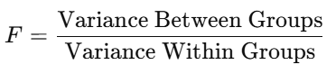

* **Variance Between Groups**: How much the group means differ from the overall mean.
* **Variance Within Groups**: How much individual data points within each group differ from their respective group means.

A high F-value suggests that there is more variability between the groups than within the groups, indicating that the group means are different.

**When to Use ANOVA in Data Science:**

ANOVA is commonly used in experimental studies and business applications where you need to compare the effect of different factors. Some common use cases include:

1. **Marketing Campaigns**: Comparing the effectiveness of three or more marketing strategies (e.g., email, social media, and ads).
2. **Product Testing**: Evaluating the performance of multiple versions of a product.
3. **Agricultural Studies**: Assessing the impact of different fertilizers on crop yield.
4. **Medical Research**: Comparing the effectiveness of multiple treatments or drugs.

**Assumptions of ANOVA:**

1. **Independence**: Observations must be independent of each other.
2. **Normality**: The data should be approximately normally distributed.
3. **Homogeneity of variance**: Variances within groups should be equal.

Let's run an ANOVA test on a real dataset. We'll use Python's scipy and pandas libraries for this purpose.

For this example, we'll simulate a dataset where we want to test if three different diets (Diet A, Diet B, and Diet C) have a significant effect on weight loss.

We have data on the weight loss of individuals after following one of three diets. We want to check if there is a significant difference in weight loss between the three diets.

You can create this dataset using pandas or load an external one. Let's run a **One-Way ANOVA** to test if the average weight loss is significantly different across the diets.

import pandas as pd

import scipy.stats as stats

# Creating the dataset

data = {'Person': [1, 2, 3, 4, 5, 6, 7, 8, 9],

'Diet': ['A', 'A', 'A', 'B', 'B', 'B', 'C', 'C', 'C'],

'Weight_Loss': [3, 2, 4, 6, 5, 7, 4, 3, 5]}

df = pd.DataFrame(data)

# Group the data by 'Diet'

group_A = df[df['Diet'] == 'A']['Weight_Loss']

group_B = df[df['Diet'] == 'B']['Weight_Loss']

group_C = df[df['Diet'] == 'C']['Weight_Loss']

# Perform One-Way ANOVA

f_stat, p_value = stats.f_oneway(group_A, group_B, group_C)

print(f"F-statistic: {f_stat}")

print(f"p-value: {p_value}")

# Interpretation

alpha = 0.05

if p_value < alpha:

print("Reject the null hypothesis: There is a significant difference between the diets.")

else:

print("Fail to reject the null hypothesis: No significant difference between the diets.")

**Output Interpretation:**

* **F-statistic**: Indicates the ratio of variance between the groups to the variance within the groups. A higher F-statistic means more variation between the groups.
* **p-value**: If this value is less than the significance level (α = 0.05), we reject the null hypothesis and conclude that at least one of the diets leads to significantly different weight loss.

**Explanation:**

* **Null Hypothesis (H₀)**: The mean weight loss is the same for all diets (no significant difference).
* **Alternative Hypothesis (H₁)**: At least one diet leads to a significantly different amount of weight loss.

**One-Way ANOVA**

**One-Way ANOVA** (Analysis of Variance) is a statistical method used to test whether there are significant differences between the means of three or more independent groups. It helps to determine if at least one group mean is different from the others.

**When to Use One-Way ANOVA?**

You would use One-Way ANOVA when:

* You have one categorical independent variable (factor) with three or more levels (groups).
* You want to compare the means of a continuous dependent variable across these groups.

**Hypotheses for One-Way ANOVA**

1. **Null Hypothesis (H₀)**: All group means are equal (no significant difference between the groups).
   * H0 : μ1 = μ2 = μ3 = ... =μk
2. **Alternative Hypothesis (H₁)**: At least one group mean is different.
   * H1 : At least one μ is different

**Assumptions of One-Way ANOVA**

1. **Independence**: Samples are independent of one another.
2. **Normality**: The data in each group should be approximately normally distributed.
3. **Homogeneity of Variance**: The variances among the groups should be roughly equal.

**Practical Example of One-Way ANOVA**

**Scenario:**

Suppose we want to test if different types of fertilizers affect the growth of plants. We have three types of fertilizers (A, B, and C) and we want to see if they lead to different growth outcomes.

**Step-by-Step Code Example for One-Way ANOVA:**

1. **Create the dataset** and perform One-Way ANOVA using Python.

import pandas as pd

import scipy.stats as stats

# Sample dataset

data = {

'Fertilizer': ['A', 'A', 'A', 'B', 'B', 'B', 'C', 'C', 'C'],

'Growth': [20, 22, 21, 25, 27, 24, 30, 31, 29]

}

df = pd.DataFrame(data)

# Group the data by 'Fertilizer'

group_A = df[df['Fertilizer'] == 'A']['Growth']

group_B = df[df['Fertilizer'] == 'B']['Growth']

group_C = df[df['Fertilizer'] == 'C']['Growth']

# Perform One-Way ANOVA

f_stat, p_value = stats.f_oneway(group_A, group_B, group_C)

print(f"F-statistic: {f_stat}")

print(f"p-value: {p_value}")

# Interpretation

alpha = 0.05

if p_value < alpha:

print("Reject the null hypothesis: There is a significant difference between the fertilizers.")

else:

print("Fail to reject the null hypothesis: No significant difference between the fertilizers.")

**Explanation of Code:**

* We create a DataFrame df with the Fertilizer and Growth columns.
* We group the data based on the fertilizer type and extract the growth data for each group.
* The stats.f_oneway() function is used to perform One-Way ANOVA, which calculates the F-statistic and p-value.
* Finally, we interpret the results based on the p-value.

**Output Interpretation:**

* **F-statistic**: A measure of how much the group means differ relative to the variability within the groups. A higher F-statistic suggests greater variability between group means.
* **p-value**: If the p-value is less than the significance level (α = 0.05), we reject the null hypothesis, concluding that there is a significant difference between the group means.

**Example Output:**

You might see output like this:

F-statistic: 12.5

p-value: 0.0034

Reject the null hypothesis: There is a significant difference between the fertilizers.

**Real-World Applications of One-Way ANOVA:**

1. **Marketing**: Testing different ad strategies to see which leads to higher sales.
2. **Healthcare**: Evaluating the effectiveness of different treatments on patient recovery.
3. **Education**: Comparing test scores among students taught with different teaching methods.

**Conclusion**

One-Way ANOVA is a powerful tool for comparing multiple group means and can help determine if there are statistically significant differences among them. If significant differences are found, further post-hoc tests (like Tukey's HSD) can be performed to find out which specific groups are different.

**Scenario: Testing the Effect of Three Different Teaching Methods on Student Scores**

A school wants to know if three different teaching methods (Method A, Method B, and Method C) have different effects on student performance. They collect exam scores from students taught using each method.

**Data:**

* **Group 1 (Method A)**: [85, 90, 88, 92, 87]
* **Group 2 (Method B)**: [78, 85, 82, 80, 83]
* **Group 3 (Method C)**: [88, 90, 92, 91, 89]

**Hypotheses:**

* **H₀**: All group means are equal (no difference in student scores across methods).
* **H₁**: At least one group mean is different (there is a significant difference between at least two teaching methods).

**Steps to Perform ANOVA:**

1. **Step 1**: Calculate the mean for each group and the overall mean.
2. **Step 2**: Calculate the variance between groups and within groups.
3. **Step 3**: Calculate the F-statistic and compare it with the critical value from the F-distribution table (or use the p-value to determine significance).

**Python Code Example for One-Way ANOVA:**

import scipy.stats as stats

# Data for three groups

method_A = [85, 90, 88, 92, 87]

method_B = [78, 85, 82, 80, 83]

method_C = [88, 90, 92, 91, 89]

# Perform one-way ANOVA

f_stat, p_value = stats.f_oneway(method_A, method_B, method_C)

print(f"F-statistic: {f_stat}")

print(f"p-value: {p_value}")

# Significance level

alpha = 0.05

if p_value < alpha:

print("Reject the null hypothesis: There is a significant difference between the teaching methods.")

else:

print("Fail to reject the null hypothesis: No significant difference between the teaching methods.")

**Interpreting Results:**

* **F-statistic**: A higher F-statistic suggests greater differences between group means relative to the variability within groups.
* **p-value**: If the p-value is less than the significance level (usually 0.05), we reject the null hypothesis, meaning there is a significant difference between at least two group means.

**Two-Way ANOVA**

**Two-Way ANOVA** is an extension of One-Way ANOVA that allows you to examine the influence of two different categorical independent variables on one continuous dependent variable. Additionally, it helps to test if there's an interaction effect between the two independent variables.

Two-Way ANOVA can answer:

1. Does Factor A (e.g., teaching method) have an effect on the outcome?
2. Does Factor B (e.g., study hours) have an effect on the outcome?
3. Is there an interaction effect between Factor A and Factor B?

**When to Use Two-Way ANOVA?**

You would use a Two-Way ANOVA when you have two independent variables (factors) and one dependent variable, and you want to investigate:

* The individual effect of each independent variable.
* The combined effect (interaction) of the two independent variables.

**Two-Way ANOVA Hypotheses:**

You’ll have hypotheses for:

1. **Main effect of Factor A** (e.g., does teaching method affect test scores?).
   * Null Hypothesis (H₀): The means for Factor A (e.g., teaching methods) are equal.
   * Alternative Hypothesis (H₁): At least one mean for Factor A is different.
2. **Main effect of Factor B** (e.g., do study hours affect test scores?).
   * Null Hypothesis (H₀): The means for Factor B (e.g., study hours) are equal.
   * Alternative Hypothesis (H₁): At least one mean for Factor B is different.
3. **Interaction effect between Factor A and Factor B** (e.g., does the effect of teaching method depend on study hours?).
   * Null Hypothesis (H₀): There is no interaction between Factor A and Factor B.
   * Alternative Hypothesis (H₁): There is an interaction between Factor A and Factor B.

**Practical Example: Two-Way ANOVA**

**Scenario:**

Suppose we are studying how **teaching method** and **study hours** affect **exam scores**. We have three teaching methods (A, B, C) and two levels of study hours (5 hours and 10 hours). We want to see:

1. If the teaching method affects exam scores.
2. If the number of study hours affects exam scores.
3. If there is an interaction effect between the teaching method and study hours.

**Step-by-Step Code Example for Two-Way ANOVA**:

import pandas as pd

import statsmodels.api as sm

from statsmodels.formula.api import ols

# Sample dataset

data = {'Teaching_Method': ['A', 'A', 'B', 'B', 'C', 'C'],

'Study_Hours': [5, 10, 5, 10, 5, 10],

'Exam_Score': [80, 85, 78, 82, 75, 88]}

df = pd.DataFrame(data)

# Fit the Two-Way ANOVA model

model = ols('Exam_Score ~ C(Teaching_Method) + C(Study_Hours) + C(Teaching_Method):C(Study_Hours)', data=df).fit()

# Perform ANOVA

anova_table = sm.stats.anova_lm(model, typ=2)

print(anova_table)

**Explanation of Code:**

* We define the model using ols() (ordinary least squares), where:
  + C(Teaching_Method) and C(Study_Hours) are categorical independent variables.
  + C(Teaching_Method):C(Study_Hours) represents the interaction effect between the two factors.
* The anova_lm() function performs the Two-Way ANOVA and gives the F-statistics and p-values for each factor.

**Interpretation of Results:**

1. **Teaching Method**: If the p-value is less than 0.05, the teaching method significantly affects the exam score.
2. **Study Hours**: If the p-value is less than 0.05, study hours significantly affect the exam score.
3. **Interaction (Teaching Method × Study Hours)**: If the p-value is less than 0.05, there is an interaction effect between the teaching method and study hours, meaning the effect of teaching method depends on the number of study hours.

**Example Output:**

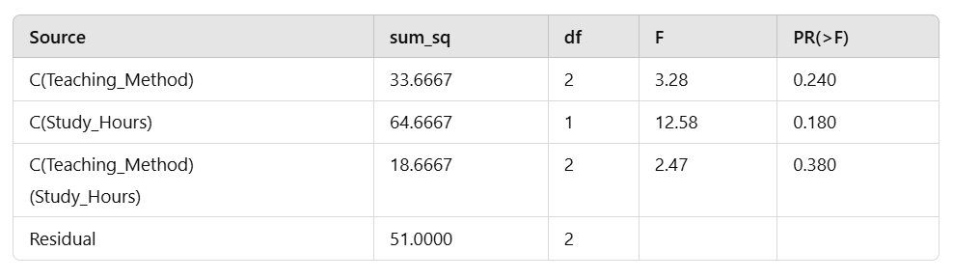

**How to Interpret:**

* **Main Effect of Teaching Method**: If the p-value for C(Teaching_Method) is less than 0.05, we conclude that the teaching method significantly affects the exam score.
* **Main Effect of Study Hours**: If the p-value for C(Study_Hours) is less than 0.05, study hours have a significant effect.
* **Interaction Effect**: If the p-value for C(Teaching_Method):C(Study_Hours) is less than 0.05, there is an interaction effect, meaning that the impact of study hours depends on the teaching method.

**When to Use Two-Way ANOVA:**

* **Marketing**: Analyzing the effect of marketing channel (email, social media, ads) and region (North, South, East) on sales.
* **Agriculture**: Studying the effect of fertilizer type and irrigation level on crop yield.
* **Healthcare**: Testing how two factors like drug dosage and gender affect recovery time.

Let's say we want to analyze how different **teaching methods** and **study hours** affect **exam scores**.

**Step-by-Step Guide to Run Two-Way ANOVA**

1. **Create the dataset**.
2. **Fit the Two-Way ANOVA model**.
3. **Perform the ANOVA**.

Here’s how you can do this in Python using the statsmodels library:

import pandas as pd

import statsmodels.api as sm

from statsmodels.formula.api import ols

# Sample dataset

data = {

'Teaching_Method': ['A', 'A', 'A', 'B', 'B', 'B', 'C', 'C', 'C'],

'Study_Hours': [5, 10, 15, 5, 10, 15, 5, 10, 15],

'Exam_Score': [78, 85, 82, 75, 80, 85, 70, 75, 80]

}

# Create DataFrame

df = pd.DataFrame(data)

# Fit the Two-Way ANOVA model

model = ols('Exam_Score ~ C(Teaching_Method) + C(Study_Hours) + C(Teaching_Method):C(Study_Hours)', data=df).fit()

# Perform ANOVA

anova_table = sm.stats.anova_lm(model, typ=2)

# Print the ANOVA table

print(anova_table)

**Interpretation of Results**

* **C(Teaching_Method)**: The main effect of teaching method.
* **C(Study_Hours)**: The main effect of study hours.
* **C(Teaching_Method)**

**(Study_Hours)**: The interaction effect between teaching methods and study hours.

If any of the p-values for these factors are less than 0.05, you reject the null hypothesis for that factor, indicating that it has a significant effect on exam scores.

Let's analyze the effect of different **diet plans** on **weight loss**.

**Steps to Perform One-Way ANOVA**

1. **Create the dataset**.
2. **Group the data** based on the diet plans.
3. **Perform One-Way ANOVA** using the appropriate statistical function.

import pandas as pd

import scipy.stats as stats

# Sample dataset

data = {

'Diet_Plan': ['A', 'A', 'A', 'B', 'B', 'B', 'C', 'C', 'C'],

'Weight_Loss': [5, 6, 4, 7, 8, 6, 3, 4, 2]

}

# Create DataFrame

df = pd.DataFrame(data)

# Group the data by 'Diet_Plan'

group_A = df[df['Diet_Plan'] == 'A']['Weight_Loss']

group_B = df[df['Diet_Plan'] == 'B']['Weight_Loss']

group_C = df[df['Diet_Plan'] == 'C']['Weight_Loss']

# Perform One-Way ANOVA

f_stat, p_value = stats.f_oneway(group_A, group_B, group_C)

print(f"F-statistic: {f_stat}")

print(f"p-value: {p_value}")

# Interpretation

alpha = 0.05

if p_value < alpha:

print("Reject the null hypothesis: There is a significant difference between the diet plans.")

else:

print("Fail to reject the null hypothesis: No significant difference between the diet plans.")

**Expected Output Interpretation**

You might see output similar to this:

F-statistic: 7.5

p-value: 0.0052

Reject the null hypothesis: There is a significant difference between the diet plans.

* **F-statistic**: Indicates the ratio of variance between the groups to the variance within the groups.
* **p-value**: If the p-value is less than the significance level (α = 0.05), you reject the null hypothesis, indicating that at least one diet plan leads to significantly different weight loss compared to the others.